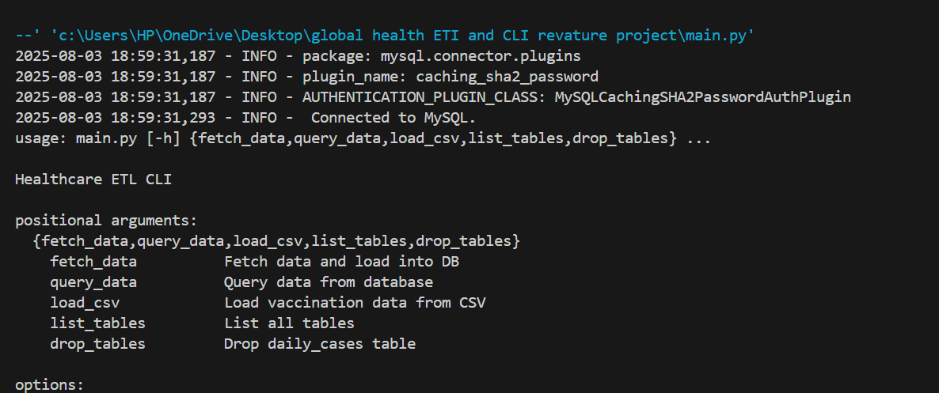

python main.py list_tables

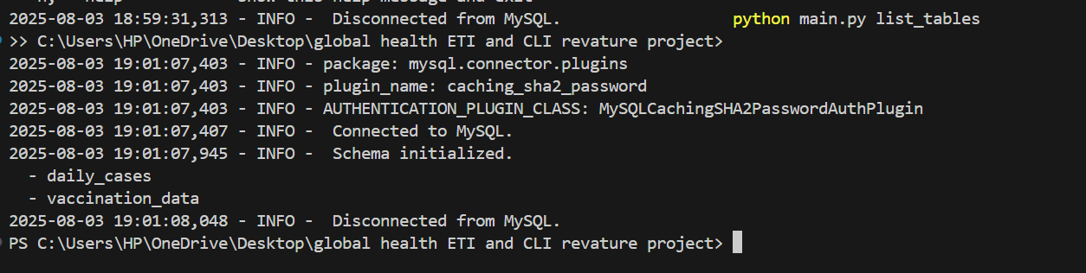

python main.py fetch_data --country "India"

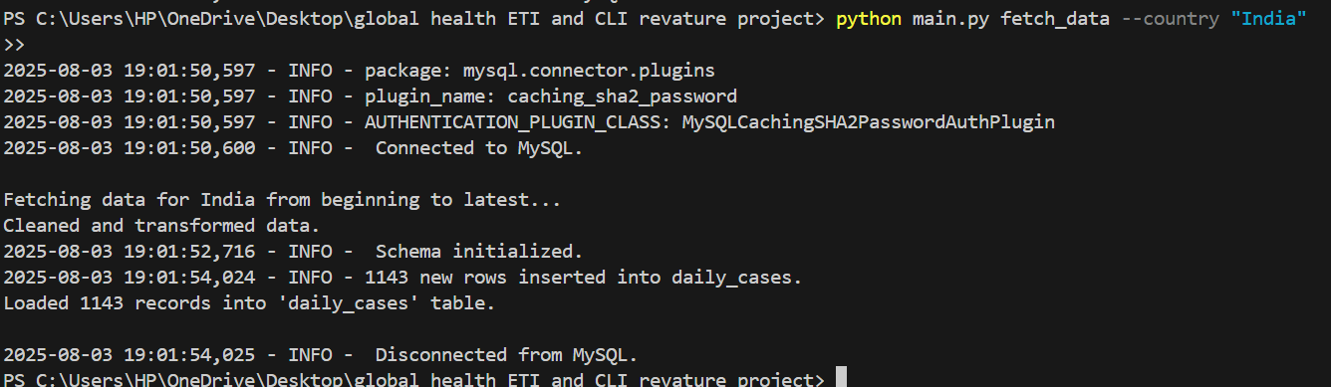

python main.py fetch_data --country "India" --start_date 2023-01-01 --end_date 2023-01-31

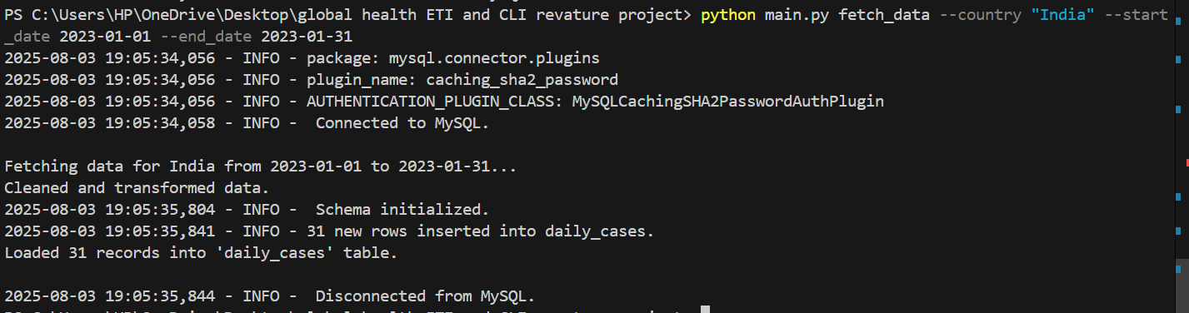

python main.py drop_tables

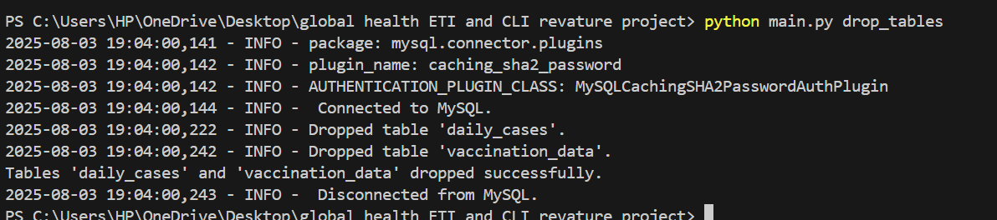

python main.py fetch_data --country "United States"

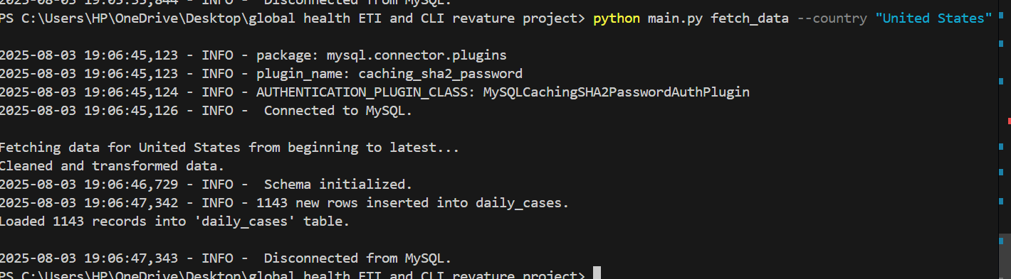

python main.py fetch_data --country "United States" --start_date 2023-01-01 --end_date 2023-01-31

python main.py query_data top_n_countries_by_metric 5 total_cases

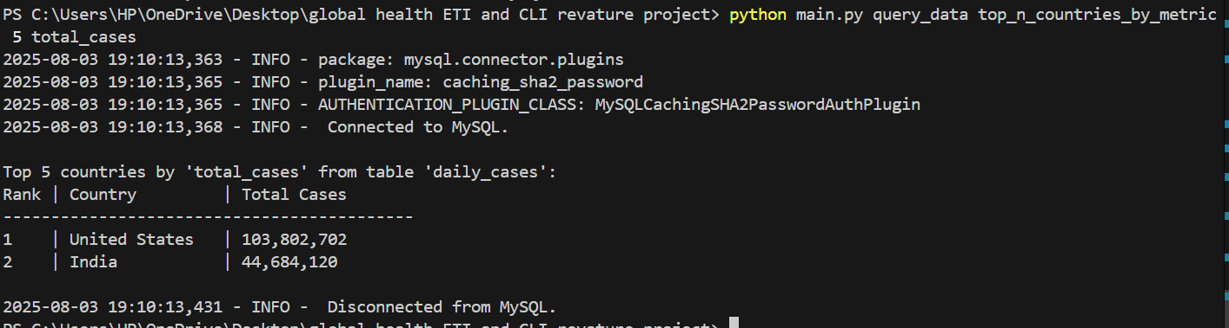

python main.py query_data daily_trends "India" new_cases

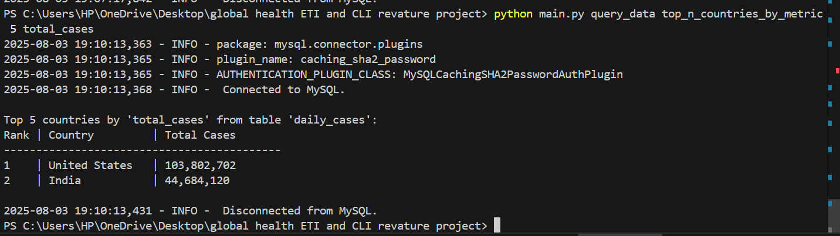

python main.py load_csv "vaccinations.csv"

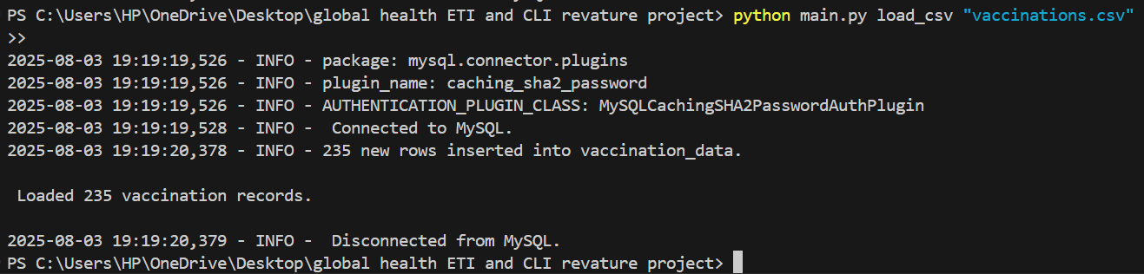

python main.py query_data total_cases India

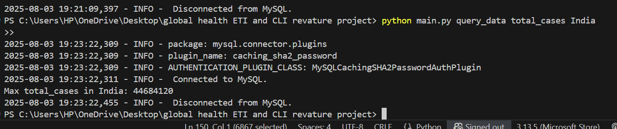

python main.py query_data top_n_countries_by_metric 5 total_vaccination

